George Orwell’s 1984 and Political Fiction Now
ASCI 1138 (Spring 2018) 1 Semester Hour Credit, S/U
Professor Thomas S. Davis (davis.3186@osu.edu)
Office Hours:
Mailbox: Denney Hall 421

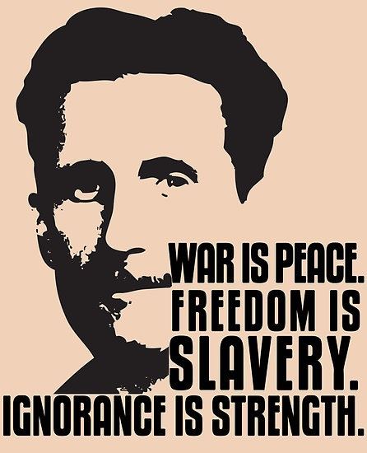

Course Description
Alternative facts, fake news, authoritarianism, political fear, dehumanization: our current political climate feels unique and without precedent. And yet it spurred enough interest in Orwell’s classic dystopian novel 1984 that the publisher reported a 9500% increase in sales since the presidential inauguration, leading some outlets like Amazon to sell out completely. Why would a novel published in 1948 appear relevant today? Is this renewed popularity a sign of its explanatory power? Does it speak to a broader mood of political paranoia? This class will start with 1984 to tease out how fiction engages in political thinking and examine the ways political interests have employed fiction and the arts to achieve their ends. We will examine 1984 in its post-WWII historical context and track how it has been used over the last 60 years. We will then turn our attention to two contemporary political novels: Ali Smith’s Autumn (2016), the first post-Brexit novel, and Kazuo Ishiguro’s Never Let Me Go (2006), which is widely considered to be one of the most stirring meditations on what it means to be human, and who gets to be human, in the 21st century. As we move through these three novels we will ask what conceptual tools and consolations fiction offers in times of historical and political distress.

Required Texts
George Orwell 1984
Kazuo Ishiguro Never Let Me Go
Ali Smith Autumn

Course Assignments
Grade Scale: S/U, upon completion of all assignments
Participation: 60%
This is an intensive seminar that requires consistent participation from all members. I expect that you have read and thought carefully about all of the material. Each student will bring two questions or observations about the readings to every class.
Roundtable Discussions 40%
Each student will participate in a roundtable discussion. For each novel, a small group of students will present some questions, arguments, and provocations for the class to take up. Sign up on Carmen and further details on handout.
Course Policies
Attendance is mandatory and will be taken at each class session. Students are allowed to miss 1 class without penalty. Further unexcused absences will result in a "U" for the final grade. The student remains responsible for any information or assignments given out during missed classes. Official documentation for an absence (doctor’s note, note from the counseling center, etc.) must be submitted electronically and approved by me.

Academic Misconduct
It is the responsibility of the Committee on Academic Misconduct to investigate or establish procedures for the investigation of all reported cases of student academic misconduct. The term “academic misconduct” includes all forms of student academic misconduct wherever committed; illustrated by, but not limited to, cases of plagiarism and dishonest practices in connection with examinations. Instructors shall report all instances of alleged academic misconduct to the committee (Faculty Rule 3335-5-487). For additional information, see the Code of Student Conduct (http://studentlife.osu.edu/pdfs/csc_12-31-07.pdf).

Resources
Students with disabilities that have been certified by the Office for Disability Services will be appropriately accommodated and should inform the instructor as soon as possible of their needs. The Office for Disability Services is located in 098 Baker Hall; telephone 292-3307, TDD 292-0901; http://www.ods.ohio-state.edu/

Class Schedule
Week One: Introduction: Political Fiction
August 25
- Introduction, Syllabus Review, & Expectations

Week Two: George Orwell and Dystopian Fiction: Power, Deception, and Character
September 1

- George Orwell 1984

Week Three: George Orwell and Dystopian Fiction: The Question of Freedom
September 8
- George Orwell 1984

Week Four: 1984 After 1948
September 15
- George Orwell 1984

Week Five: George Orwell and Dystopian Fiction
September 22

- ROUNDTABLE ON GEORGE ORWELL

Week Six: Fiction Now (I): Writing in the Midst of Crisis
September 29

- Ali Smith Autumn

Week Seven: Fiction Now (I): Writing in the Midst of Crisis
October 6

- Ali Smith Autumn

Week Eight: FALL BREAK, NO CLASS
October 13

Week Nine: Fiction Now (I): Writing in the Midst of Crisis
October 20

- Ali Smith Autumn

Week Ten: Fiction Now (I): Writing in the Midst of Crisis
October 27

- ROUNDTABLE ON ALI SMITH

Week Eleven: Fiction Now (II): The Human & Inhuman
November 3

- Kazuo Ishiguro Never Let Me Go

Week Twelve: Fiction Now (II): The Human & Inhuman
November 10
- Kazuo Ishiguro Never Let Me Go

Week Thirteen: Fiction Now (II): The Human & Inhuman
November 17
- Kazuo Ishiguro Never Let Me Go

Week Fourteen: THANKSGIVING, NO CLASS
November 24

Week Fifteen: Fiction Now (II): The Human & Inhuman
December 1

- ROUNDTABLE ON KAZUO ISHIGURO

